**Early stages of developing**

I was trying to experiment with so many things that I didn’t have much of a plan for my splash screen. I knew I wanted a background, name and button in the center of the back. Earlier I was experimenting with css shapes to make a background.

**1st splash page idea**

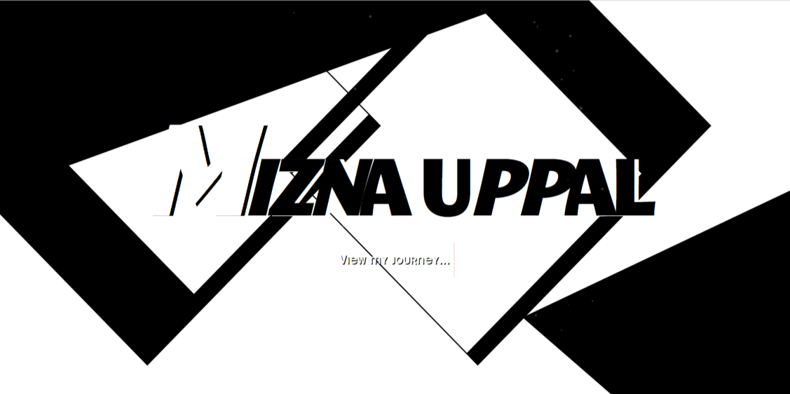

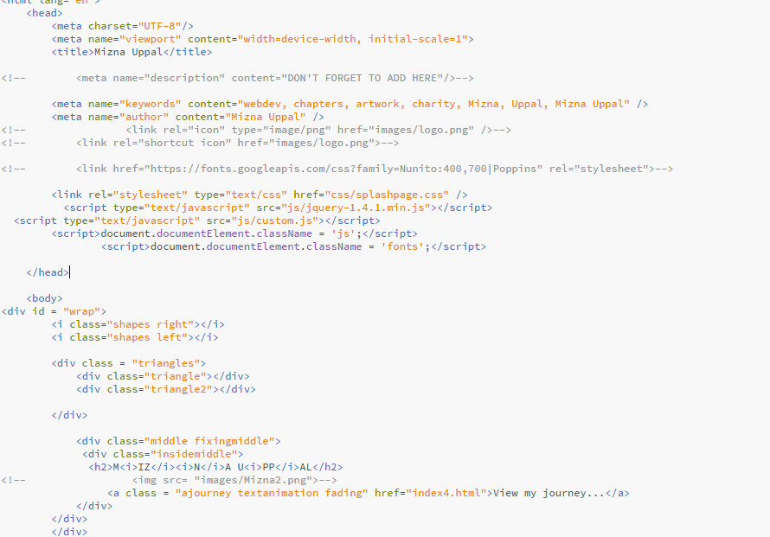

You can see that I am trying to use many shapes and order them/ structure them in a way that affects the design of the background.

**Early development of homepage**

There is not much here however at this point I had just finished the implementation of my menu bar; it was floating to the left and I was lacking structure in my HTML and CSS.

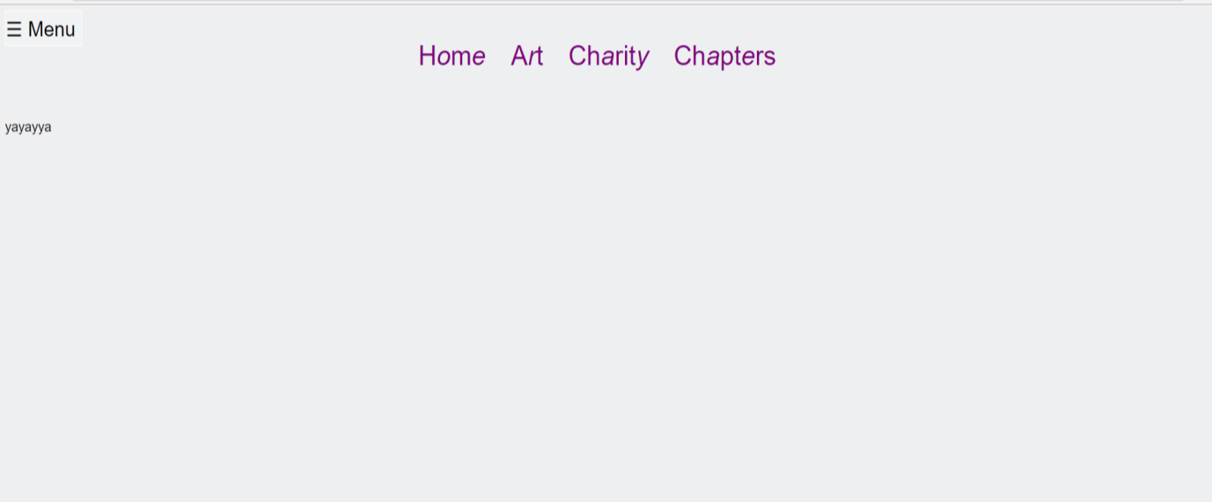

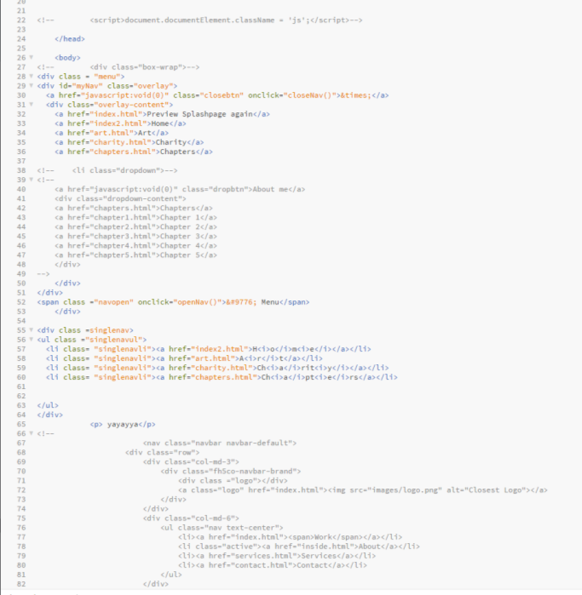

My HTML has barely any structure at the moment however my menu bar is starting to form and looks nearly complete.

**Early development of art page**

I had just finished the basic structure for the grid that I wanted on my art page. During this time, I made the grid responsive to screen width as well.

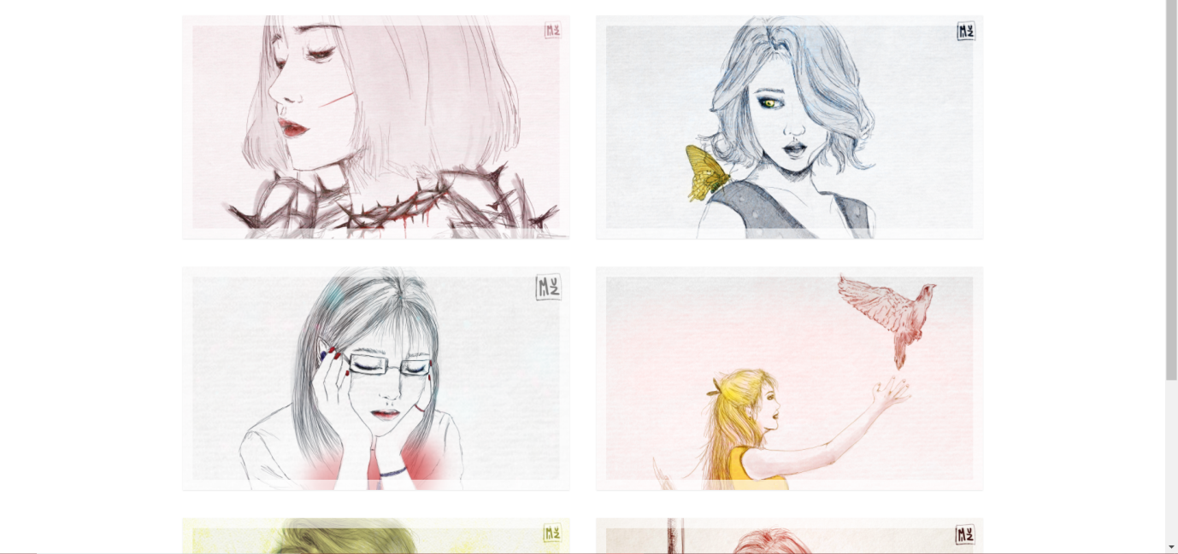

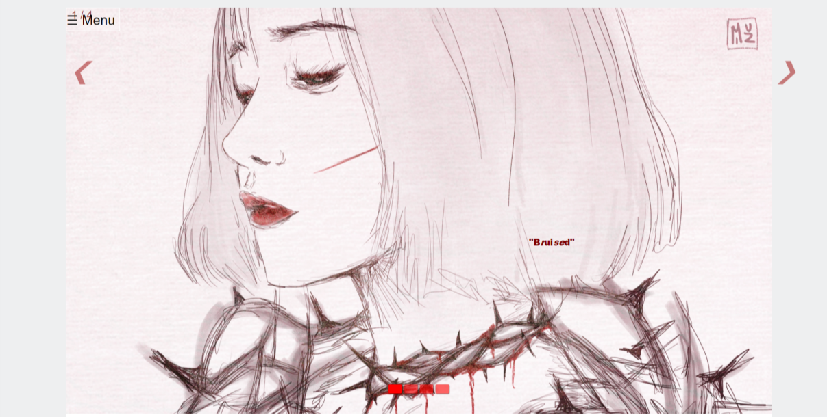

I tried to follow my design and make a slideshow that would suit the colour scheme I had chosen before which was black, red and white.

**Chapters early development**

I had found this interesting css transitions template and I was trying to get my head around how they structured it and styled it and if I could use a similar technique on my chapters page.

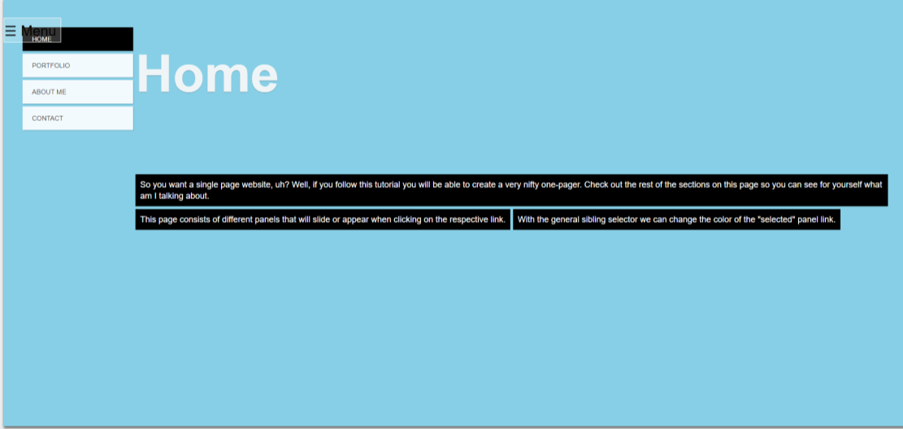

**Art page progress**

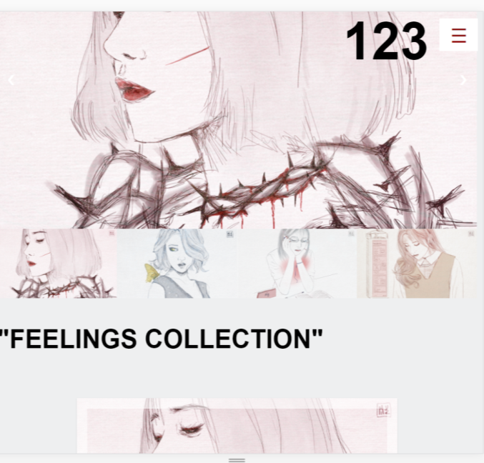

Art page finally started to take shape; I added the preview images at the bottom and a caption at the top of the container that has slideshow. There is a fixed menu at the top. I still have a red and black and white theme.

**Chapters progress**

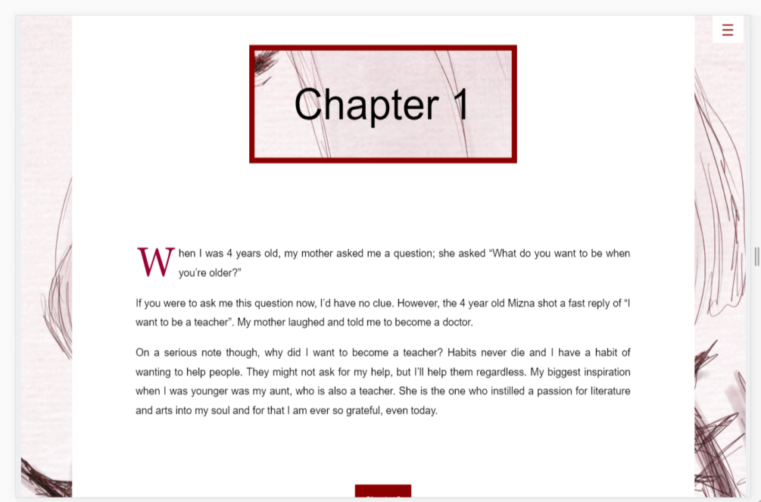

My “chapters” page was finally starting to take form however my pages were still lacking an appealing colour scheme. My website was also not responsive therefore I needed to fix that.

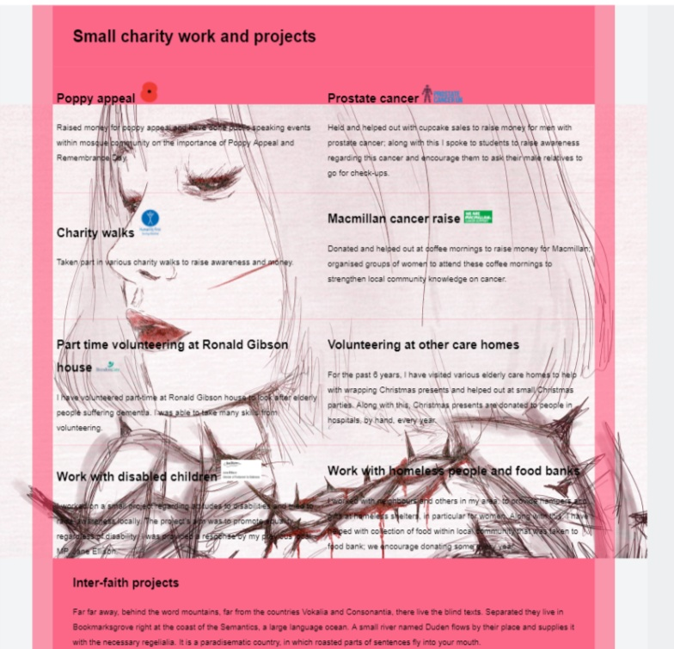

I started working on my charity page however my work needed a lot of structure so I tried to figure out how I could do that. At this point I had decided that I wanted to go with a pink and black colour scheme.

**Homepage**

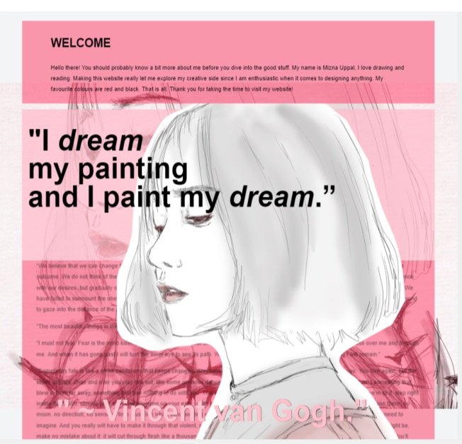

After many trials and errors, I came up with this design for my homepage. The orginal idea was to have two columns with one column that has my quote and the other that has this image. I was originally going to make my drawing into a gif but I felt that would over-do the bold theme.

**Charity page progress**

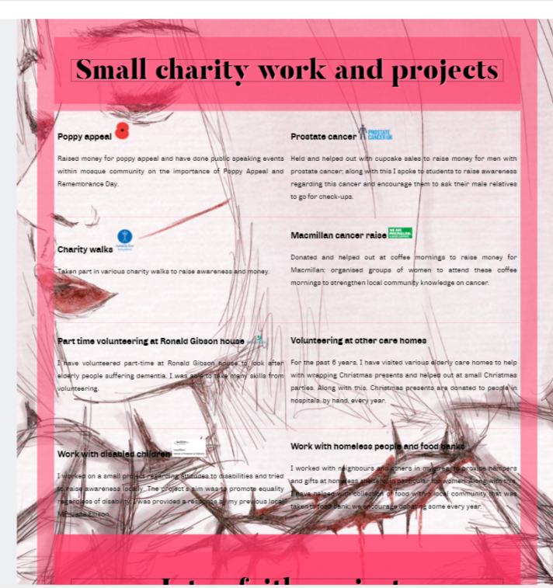

I had started to add media queries in order to make the charity page more responsive. I wanted to have an image background for scroll effect however this hinders the user’s ability to read the text hence why I decided to give it a different background.

**Splashpage without any CSS OR JS.**

I have kept the footer on this page however the body covers it therefore you cannot actually see it. Since there are no other links on the page, I assumed a footer would remain important.



**Homepage without any CSS or JS.**

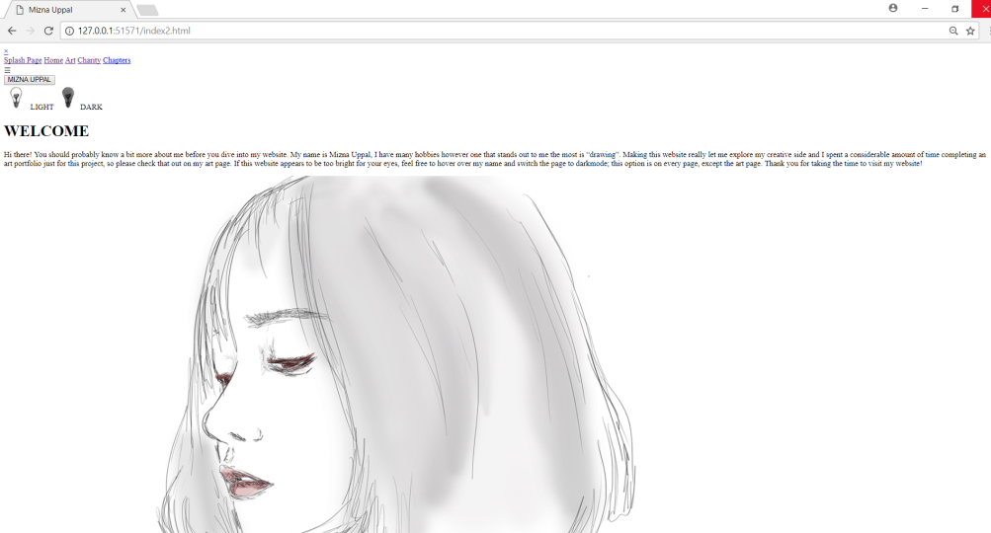

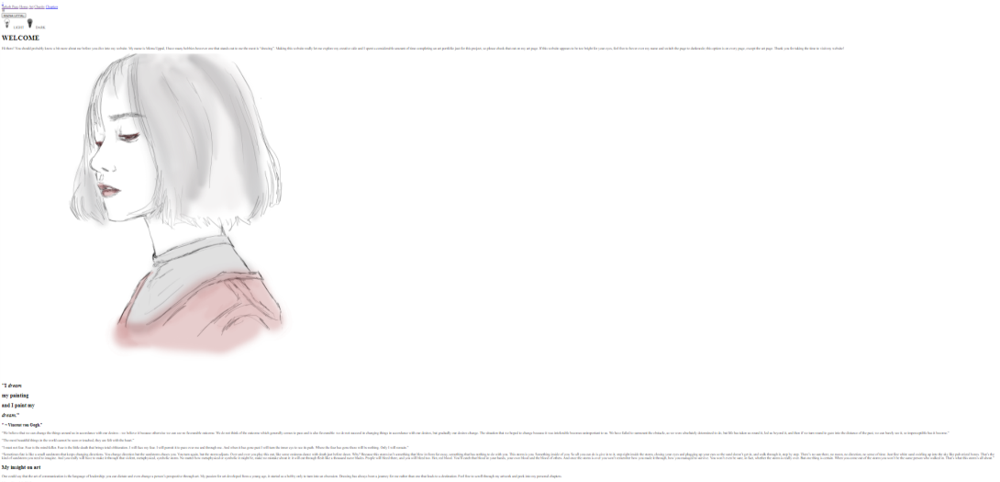

**Art page without any CSS or JS**

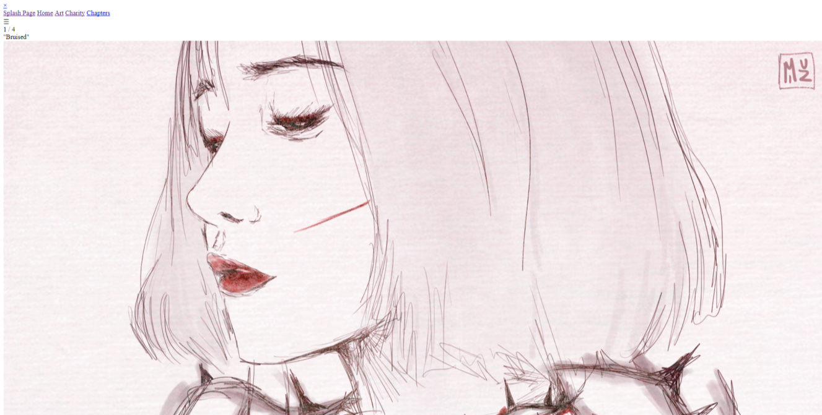

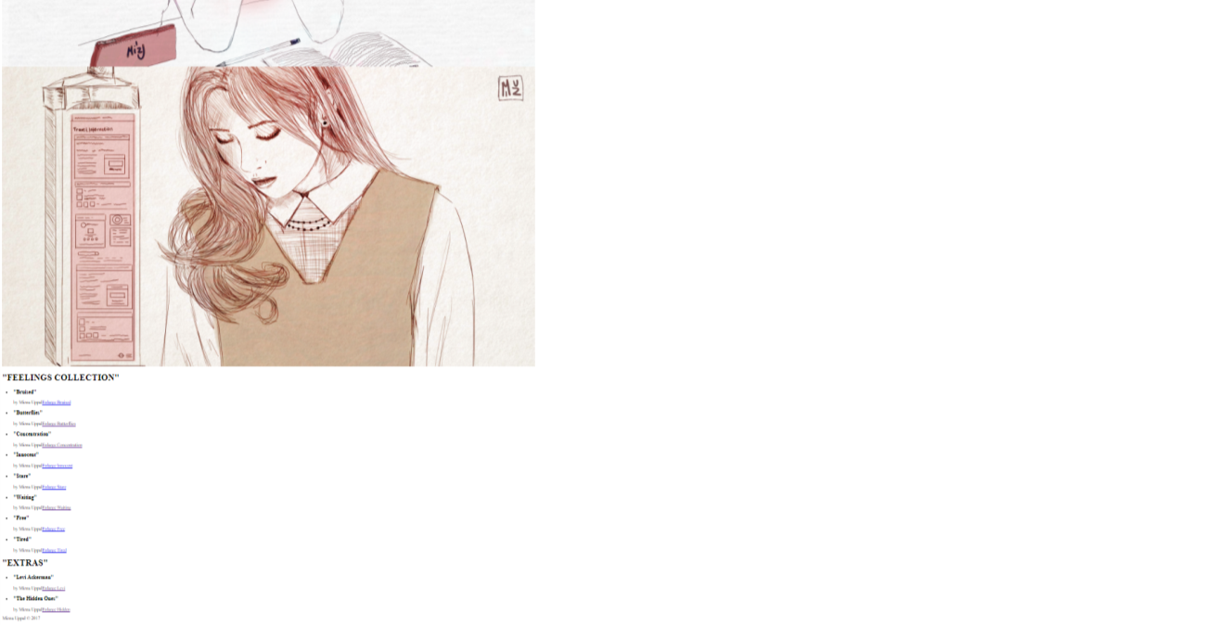

Charity page without any CSS or JS

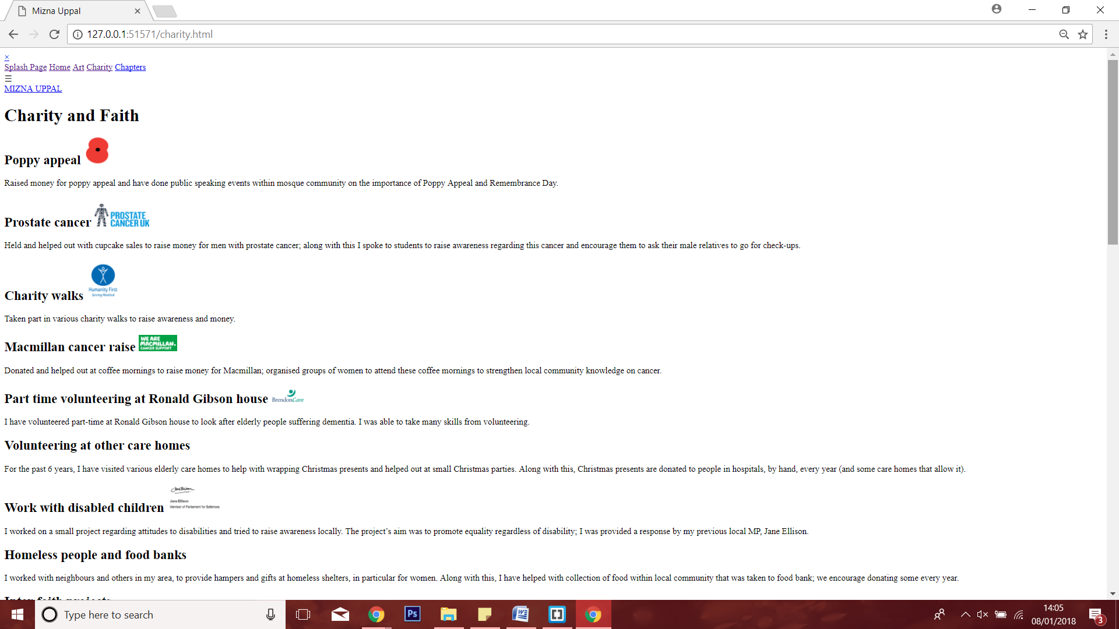

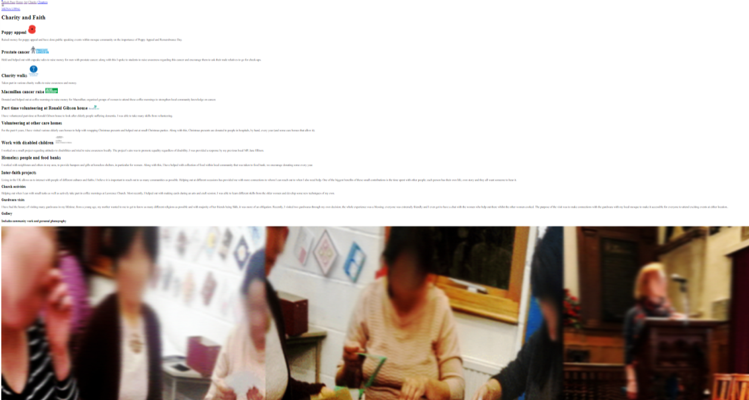

**Chapters page without any CSS or JS**

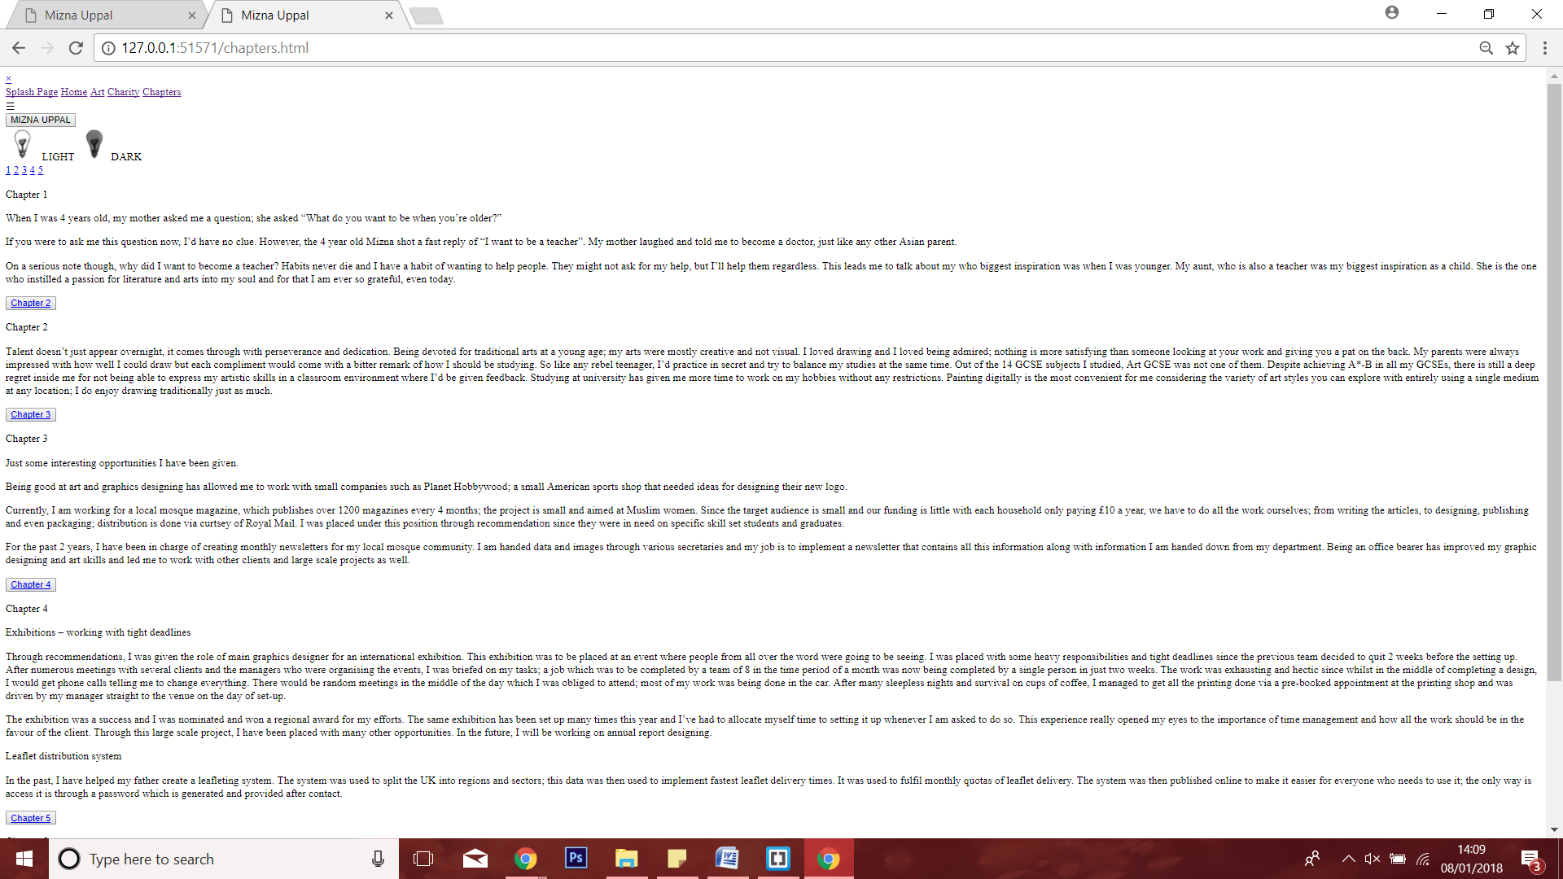

**Final website**

**Splash page at full width:**



**Home page:**

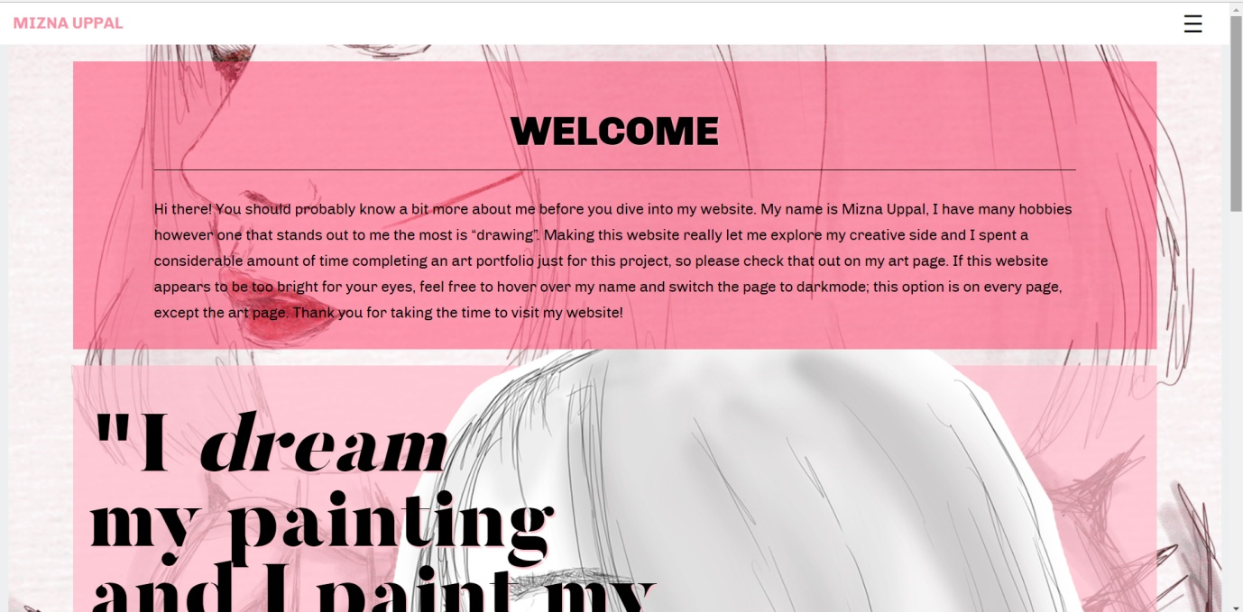

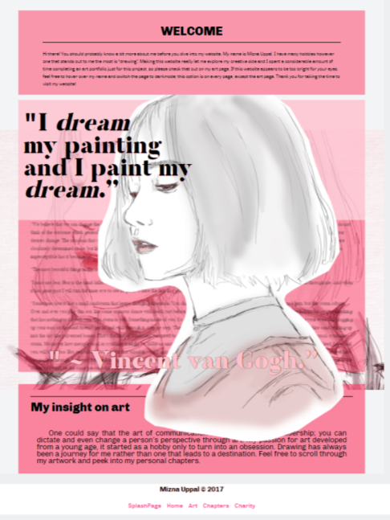

**IMPACT OF JAVASCRIPT**

**LIGHT AND DARK**

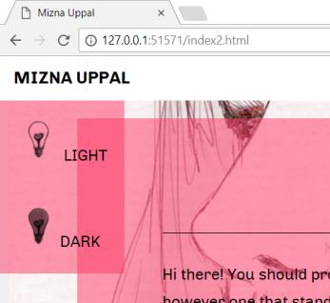

Upon hovering over my name, this little drop down box comes up, it will allow the user to switch between light and dark mode. The current pink, white and black colour scheme is the “light” and upon clicking dark. We get a grey colour scheme which is a lot easier on the eyes.

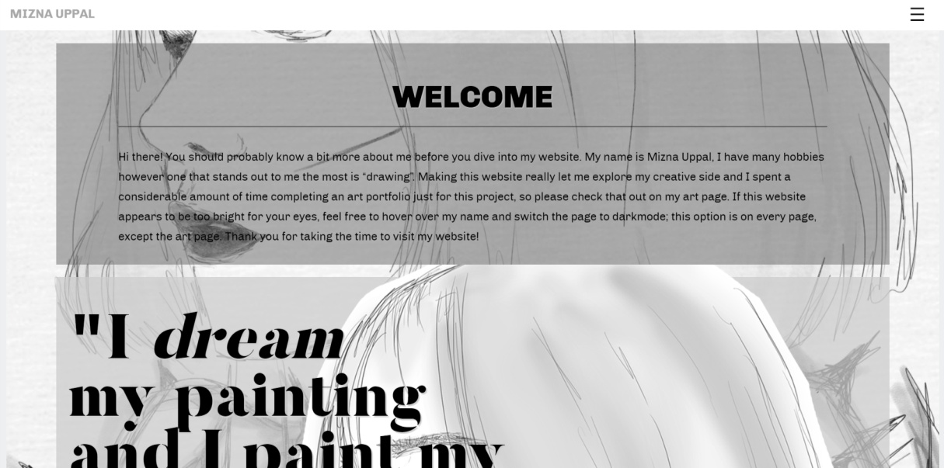

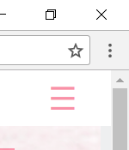

Upon clicking on this small navigation icon at the top of the page, we can use javascript to open our full page navigation.

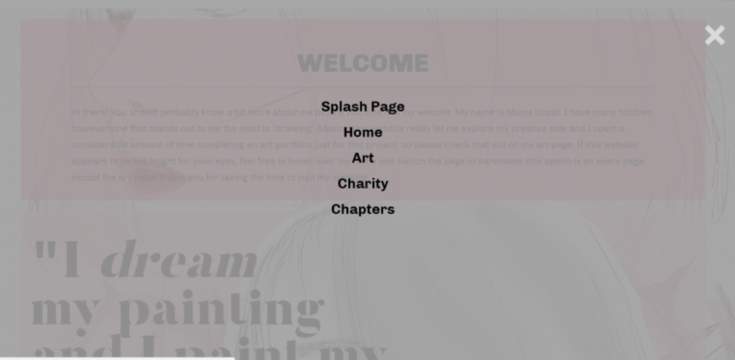

**Splash screen design**



Upon hover, we get little tiny ink stains; this is for design purposes. These ink stains only appear when the mouse is on screen.

**Smooth scrolling on chapters page**

 

I wanted to make it easier to users to jump from one place to another since this page is quite long. The smooth scrolling is applied to the links at the top of the page and the buttons on the page as well. I used jquery library for the smooth scrolling.

**Slideshow with the use of js**



I was able to add a slideshow onto my website through javascript, this allows the user to flick through some my pictures. It also helps to make the page look aesthetically pleasing.

**Fading js code**

Fading.js used; this was originally just a simple code but I put it into a separate folder changed some parts to it; it allows the “body” part of the page to subtly fade in and out.